Phase III System Design
202322468 Mpolai Lenka

Architecture Diagram
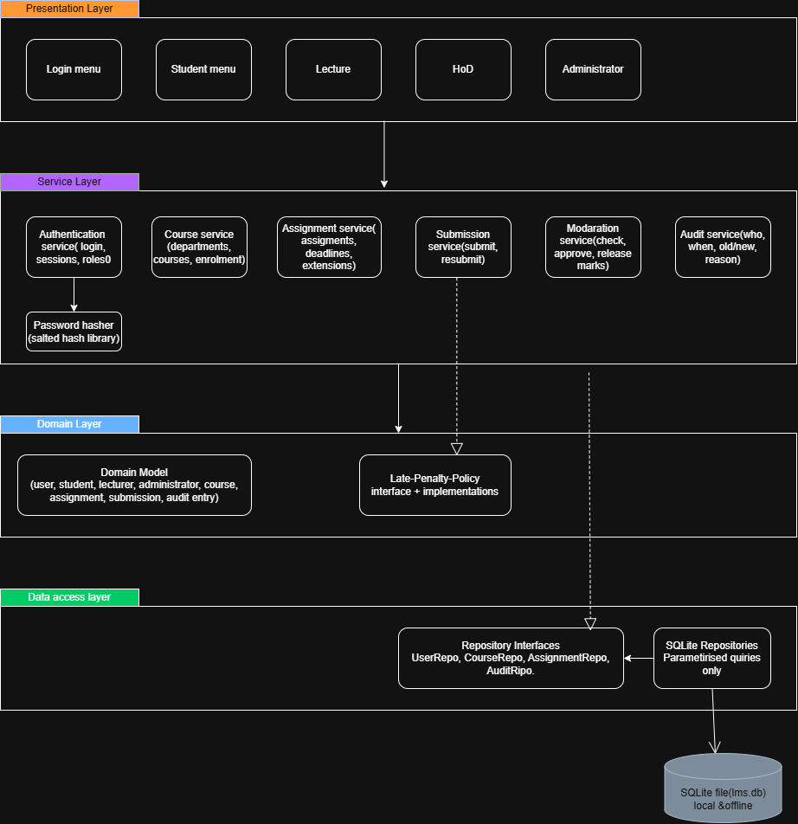

Why layered architecture:
- Separation of concerns: UI, Business rules and data access are independent of each other.
- Testability: domain and service layer can be tested independent of SQLite with just fake repositories.
- Maintainability: change such as change request 1 which arrives after the release affect only service and domain layers, not the whole system.

Model-view-controller(MVC) was rejected because:
It suits UI-centred applications with several views. This system has one console view, and the complexity is in the business rules (penalties, state transitions, moderation). A controller would absorb that logic and grow large. The menus plus the services already fill the controller’s role.
Class diagram
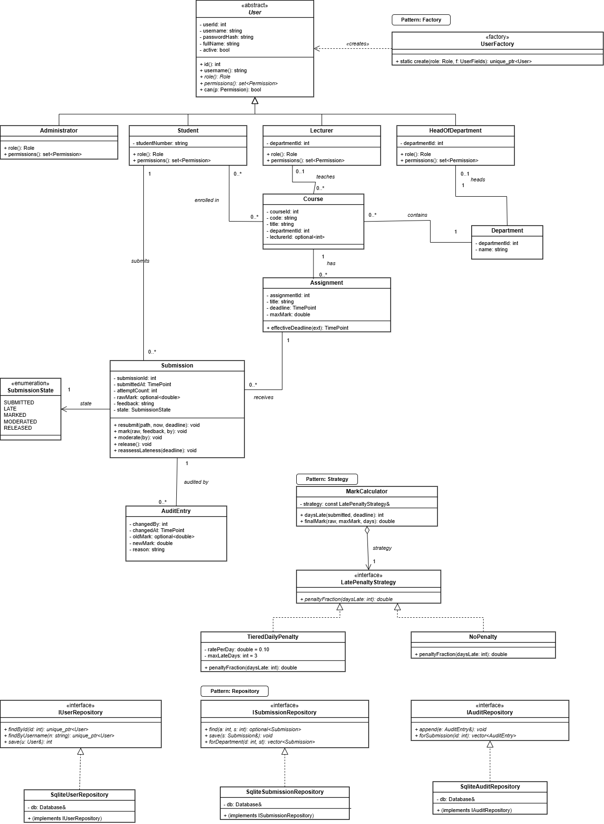

Why each pattern was chosen:

Strategy (late penalty). The late-work rule is the part most likely to change. I put each rule in its own small class, so changing the rule means adding a class and leaving the marking code alone. It’s also easy to test on its own.
- Repository (database access). All database code sits behind one interface. The rest of the system never touches SQL, so it can be tested without a real database, and the database could be swapped without rewriting the logic.
- Factory (creating users). One place decides which kind of user to create (student, lecturer, HoD or administrator) from the stored role. No other code has to know the details.
SOLID Principles Application
- Single Responsibility Principle (SRP): Each class is assigned a single responsibility. For instance, the submission entity is responsible only for storing submission data, the mark calculator handles only penalty calculations, and the SQLite submission repository manages only database persistence for submissions.
- Open/Closed Principle (OCP): The design is open for extension but closed for modification. The Strategy pattern applied to the late penalty interface allows new penalty rules to be added as new classes without modifying the mark calculator. Similarly, the Factory pattern enables the addition of new user roles without altering existing instantiation logic.
- Liskov Substitution Principle (LSP): Sub-classes can substitute their base classes without altering program correctness. The four specific roles correctly inherit from the abstract user class, meaning any role can be treated as a generic user by the authentication system.
- Interface Segregation Principle (ISP): Interfaces are specific and focused. Data access is split into distinct repository interfaces, ensuring that implementing classes are not forced to depend on methods they do not use.
- Dependency Inversion Principle (DIP): High-level modules depend on abstractions rather than concrete implementations. The mark calculator depends on the late penalty strategy interface, not a specific penalty class. Data access classes depend on repository interfaces, allowing for easier testing and decoupling from specific database technologies.
Behavioural models
- State Machine diagram for submission
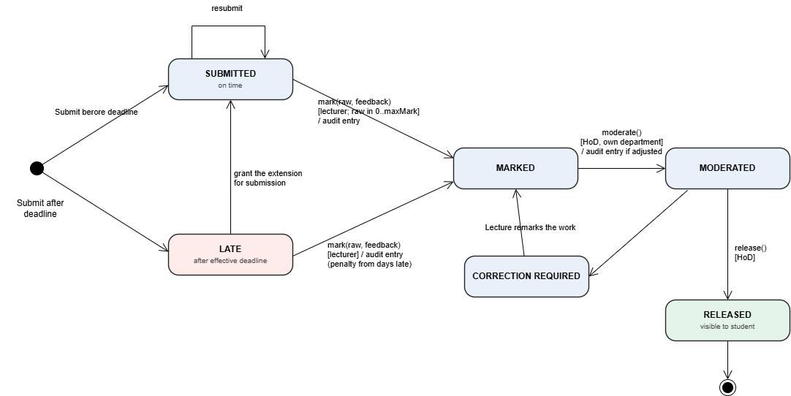
- Activity diagram
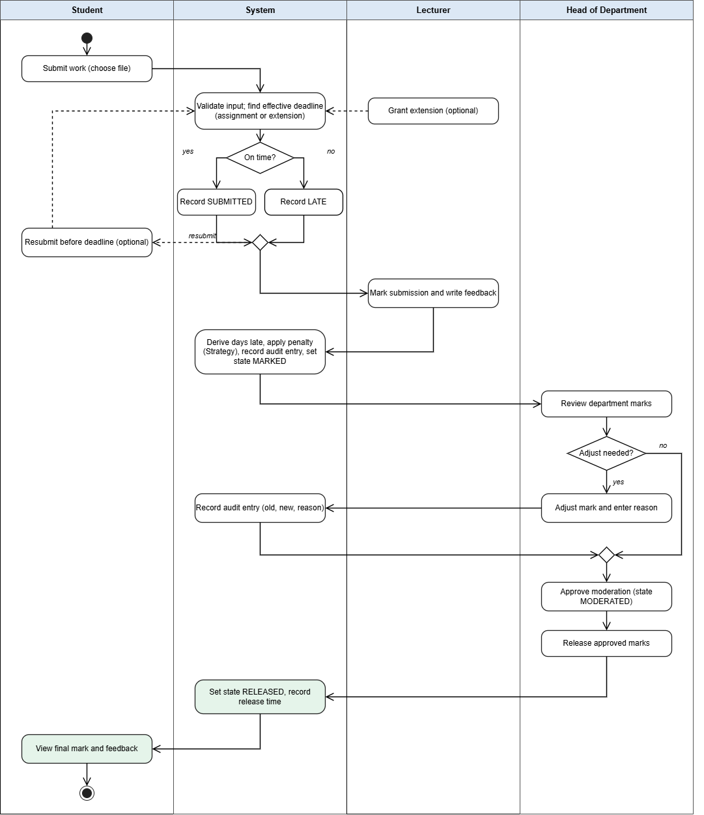
- Sequence diagram
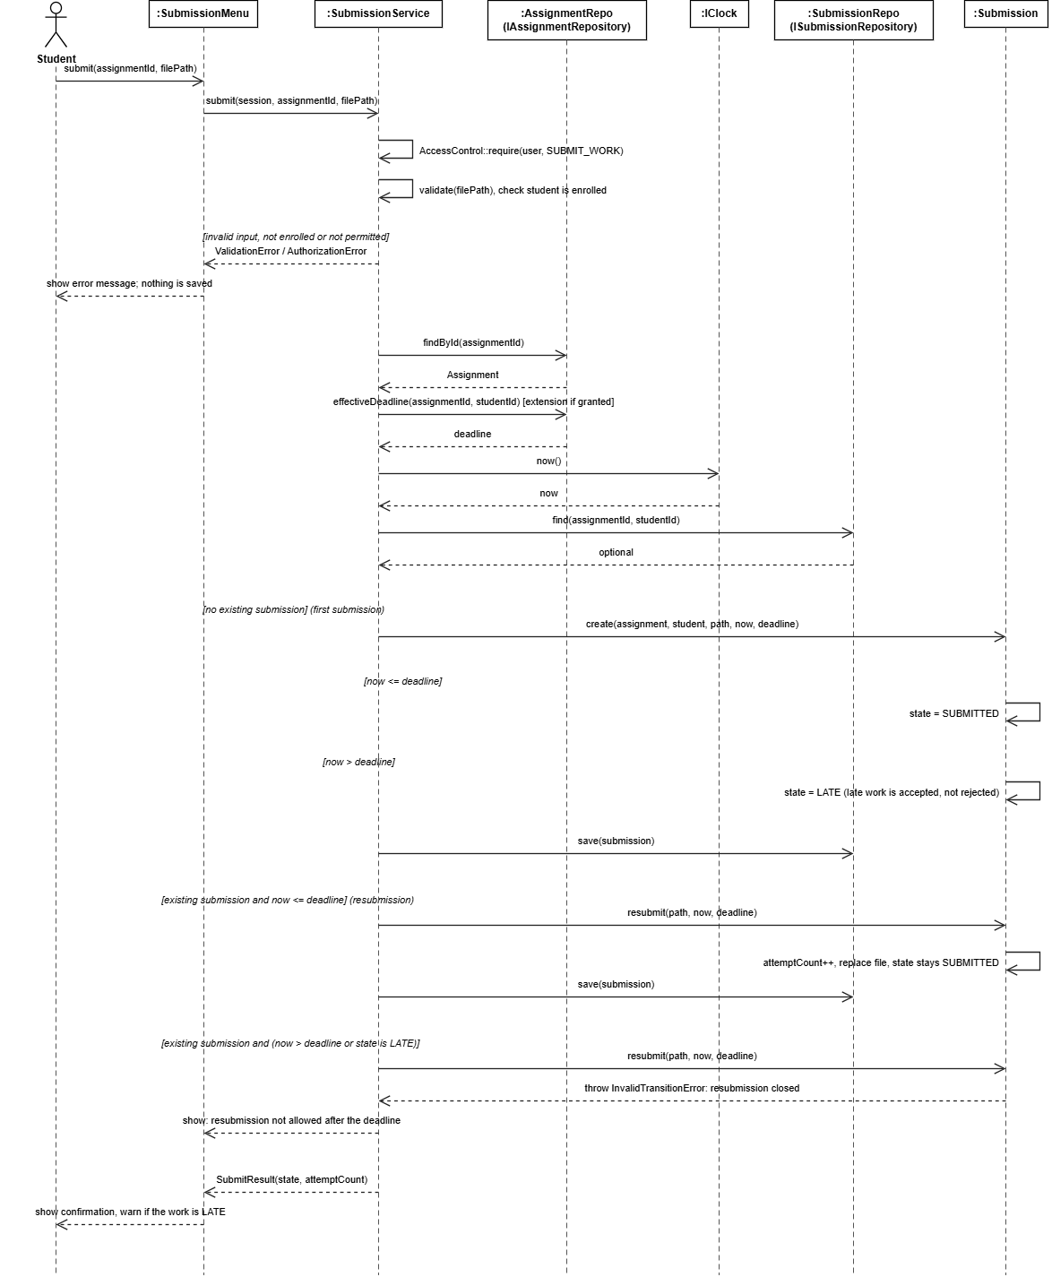

Database Design


